**INDUSTRY INTERNSHIP REPORT**

**ON**

**“Redistributing Routing Protocols”**

**AT**

**Solitaire Infosys Pvt. Ltd**

**C-110 Industrial Area, Phase-VII**

**Mohali, India**

**AN INDUSTRY INTERNSHIP REPORT SUBMITTED**

**IN PARTIAL FULFILLMENT OF THE REQUIREMENTS**

**FOR THE AWARD OF DEGREE OF**

# BACHELOR OF ENGINEERING In Computer Science and Engineering SUBMITTED BY

Rishi Mehra

2020A1R175

X



**SUBMITTED**

**TO**

**Department**

**of**

**Computer**

**Science**

**and**

**Engineering**

**Model**

**Institute**

**of**

**Engineering**

**and**

**Technology**

**Autonomous**

**)**

**(**

**Jammu,**

**India**

**2022**



**Contents**

Candidates’ Declaration

Internship Certificate

Supervisor Evaluation of Intern

Certificate

Attendance Report

Acknowledgement

# Chapter 1 INTRODUCTION `

1.1 Introduction of Redistributing Routing Protocols

1.2 Uses of the Redistributing Routing Protocols

1.3 Software and Hardware Requirements

**Chapter 2 TRAINING WORK UNDERTAKEN**

2.1 Concepts Used While Learning

2.2 Commands Used

# Chapter 3 RESULT AND CONCLUSION

3.1 Project Screenshots

3.2 Conclusion

**Chapter 4 REFERENCES**

# CANDIDATES’ DECLARATION

I, **Rishi Mehra, 2020A1R175,** hereby declare that the work which is being presented in the Industry Internship Report entitled, “**Redistributing Routing Protocols**” in partial fulfillment of requirement for the award of degree of B.E. (CSE) and submitted in the Computer Science and Engineering (CSE), Model Institute of Engineering and Technology (Autonomous), Jammu is an authentic record of my own work carried by me at “**Solitaire Infosys Pvt. Ltd, C-110 Industrial Area, Phase-VII, Mohali, India”** under the supervision and mentorship of **Shivansh Kumar (Network**

**Engineer, Department: Research and Development , Solitaire Infosys Pvt. Ltd, C- 110 Industrial Area, Phase-VII, Mohali)**. The matter presented in this report has not been submitted in this or any other University / Institute for the award of B.E. Degree.



*Signature of the Student Dated*:

**Rishi Mehra 28th Nov 2022**

**2020A1R175**

## INTERNSHIP CERTIFICATE



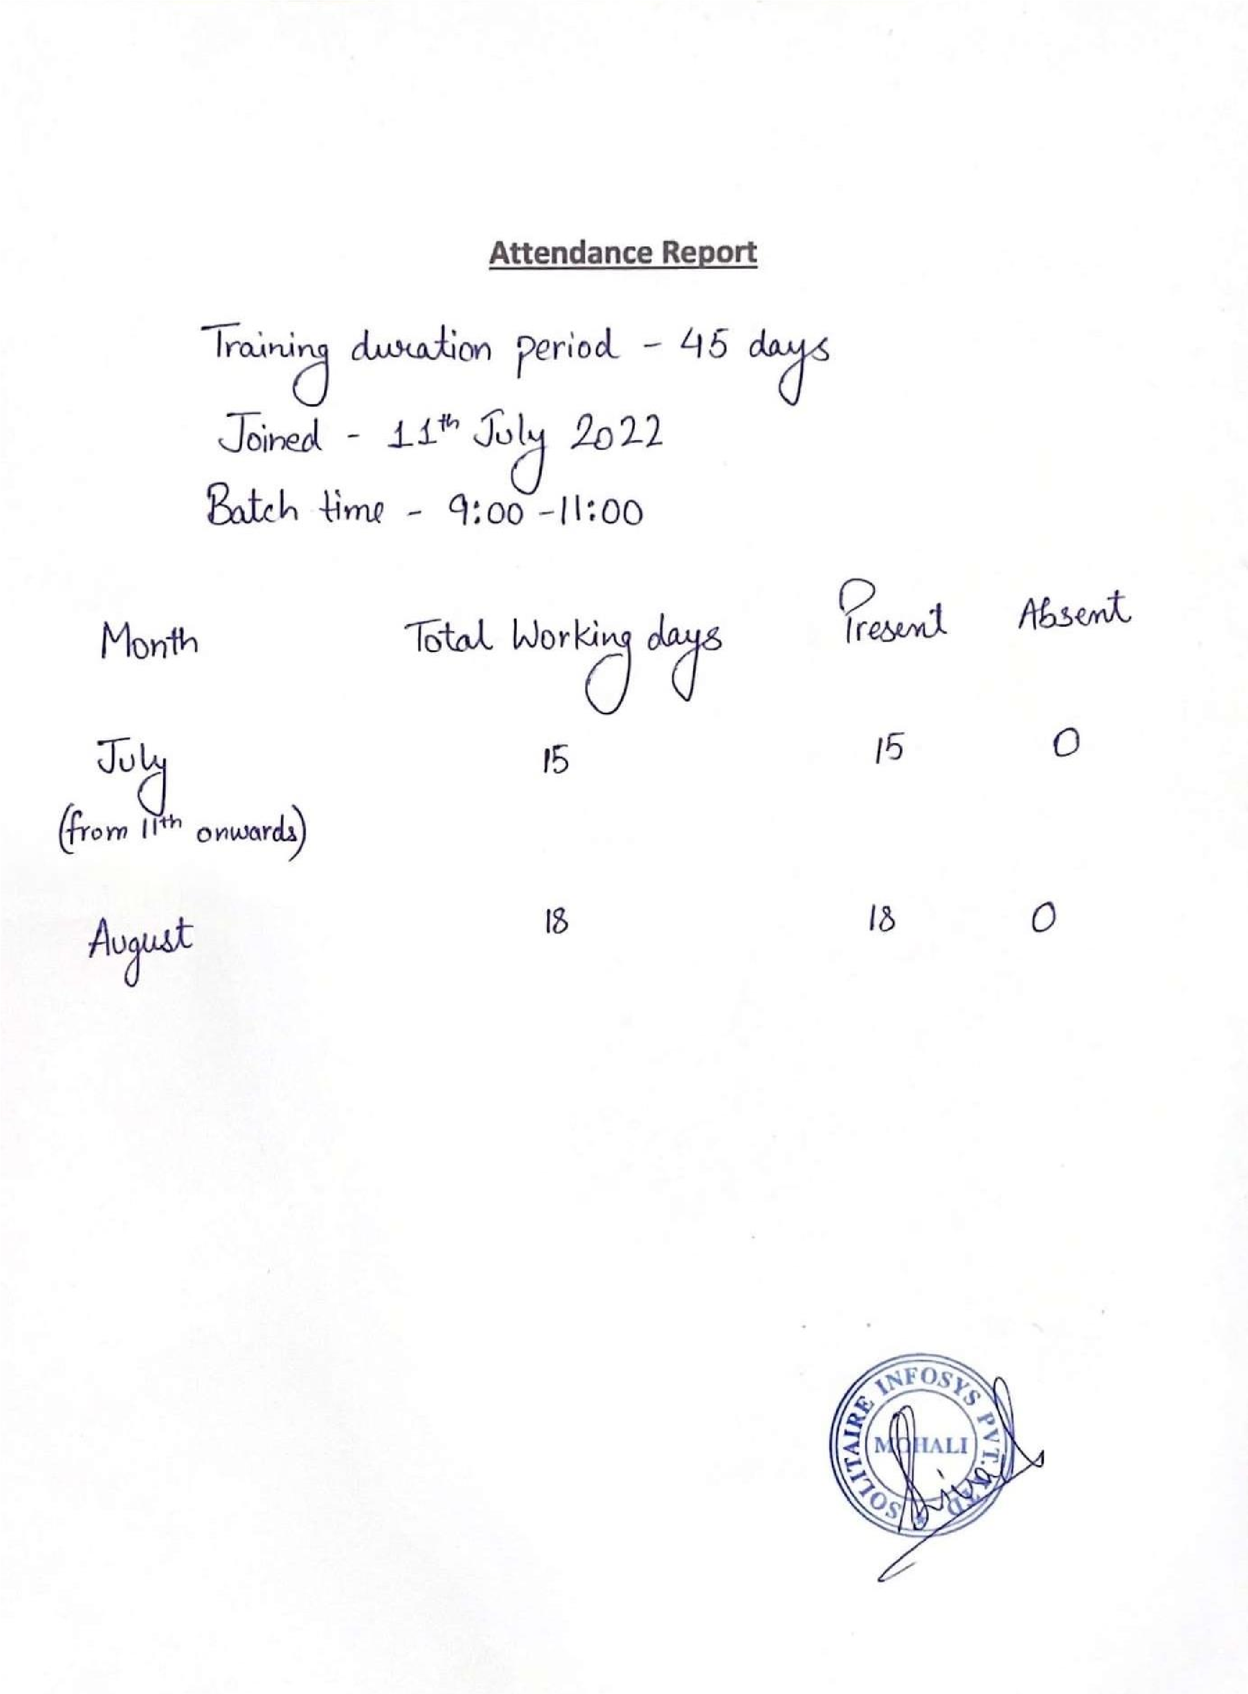

## Computer Science and Engineering

**Model Institute of Engineering and Technology (Autonomous)**

**Kot Bhalwal, Jammu, India**

***(NAAC “A” Grade Accredited)***

## Ref. No.:2020A1R175 Date:28th Nov 2022

## CERTIFICATE

Certified that this Industry Internship Report entitled **“Redistributing Routing Protocol”** is the BONAFIDE work of “**Rishi Mehra , 2020A1R175, CSE, Model Institute of Engineering and Technology (Autonomous), Jammu”,** who carried out the Industry Internship at “**Solitaire Infosys Pvt. Ltd, C-110 Industrial Area, PhaseVII Mohali, India**” work under my mentorship during 11th of July, 2022 – 25th August, 2022*.*

**Mr. Saurabh Sharma**

**Assistant Professor**

**C.S.E Department,**

**MIET**

## ACKNOWLEDGEMENTS

This Summer internship opportunity was a great chance for learning and professional development. I am grateful for having a chance to meet so many wonderful people and professionals who led me though this internship period.

It is my pleasant duty to pay my heartfelt gratitude to Mr. Shivansh Kumar, Network Engineer, Solitaire Infosys PVT. LTD who have guided me through the course of this Internship.

I must record my deep sense of gratitude to Prof. (Dr.) Ankur Gupta (Director, MIET) and Prof. (Dr.) Ashok Kumar (Dean Academics & HOD CSE, MIET) for their guidance, constant inspiration and encouragement, and for their keen involvement throughout the course of present work.

Gratitude and thanks although mean a very small thing to convey my thanks to my parents who have always given me a parental source of love, motivation and strength right from the journey of my life.

Bearing in mind previous I am using this opportunity to express my deepest gratitude and special thanks to the teachers who in spite of being extraordinarily busy with their duties, took time out to hear, guide and keep me on the correct path and allowing me to carry out my project at their esteemed organization and extending during the training.

I perceive this opportunity as a big milestone in my career development. I will strive to use gained skills and knowledge in the best possible way, and I will continue to work on their improvement, in order to attain desired career objectives. Hope to continue cooperation with all of you in the future.

I express my sincere gratitude to Solitaire Infosys Pvt. Ltd, Jammu and Model Institute of Engineering and Technology (Autonomous), Jammu for giving me the opportunity.

**Rishi Mehra**

**2020A1R175**

**CHAPTER 1: INTRODUCTION**

**1.1: REDISTRIBUTING ROUTING PROTOCOLS**

**1.1.1: WHAT IS REDISTRIBUTING ROUTING PROTOCOLS**

Redistributing Routing Protocols is a process of advertising a route learned by method of static routing, directly connected route or a dynamic routing protocol into another routing protocol.

Redistribution in networking is the importing and exporting of network routes from one routing protocol (or static routing) to another routing protocol. Routers that run two or more routing protocols can be configured for redistribution. An example is a router that runs OSPF and EIGRP, you can import the network routes from OSPF into EIGRP and vice versa. Since routing protocols use different metrics, you will have to manually assign a metric to redistributed routes.

Often, using a single routing protocol in an organization is preferred but there are some conditions in which we have to use multi-protocol routing. These conditions include multiple administration running multiple protocols, company mergers or usage of multi-vendors devices. Therefore, we have to advertise a route learned through a routing protocol or by any other means (like static route or directly connected route) in different routing protocol. This process is called Redistributing Routing Protocols.

**1.1.2: USES**

Redistribution is used to allow different networks belonging to the same company to communicate with each other.

Redistribution is used when two companies merge and their networks use different routing protocols.

Assume that RIP being used in a growing network. Beyond a hop count of 15, it will become impossible to use RIP.

In this situation, we will need to switch to another routing protocol.

While switching, two protocols would need to co-exist in the network while maintaining complete reachability.

Redistribution of routes from RIP to the new protocol and vice versa can achieve this.

# SOFTWARE AND HARDWARE REQUIREMENTS

**SOFTWARE:**

CISCO PACKET TRACER

**HARDWARE:**

PROCESSOR: i3, i5

RAM: 4GB

SUPPORTED WINDOWS: 7,8,10,11

SYSTEM TYPE: 32BIT/64BIT

**CHAPTER 2: TRAINING WORKS UNDERTAKEN**

**2.1: Concepts Used While Learning:**

**1. IP ADDRESS (INTERNET PROTOCOL):**

An IP address represents an Internet Protocol address. A unique address that identifies the device over the network. It is almost like a set of rules governing the structure of data sent over the Internet or through a local network.

Types of IP Address

IP Address is of two types:

1. IPv4: Internet Protocol version 4. It consists of 4 numbers separated by the dots. Each number can be from 0-255 in decimal numbers. But computers do not understand decimal numbers, they instead change them to binary numbers which are only 0 and 1. Therefore, in binary, this (0- 255) range can be written as (00000000 – 11111111).

1. IPv6: But, there is a problem with the IPv4 address. With IPv4,we can connect only the above number of 4 billion devices uniquely, and apparently, there are much more devices in the world to be connected to the internet. So, gradually we are making our way to IPv6 Address which is a 128-bit IP address. In human-friendly form, IPv6 is written as a group of 8 hexadecimal numbers separated with colons(:). But in the computer- friendly form, it can be written as 128 bits of 0s and 1s. Since, a unique sequence of binary digits is given to computers, smartphones, and other devices to be connected to the internet. So, via IPv6 a total of devices can be assigned with unique addresses which are actually more than enough For upcoming Future generations.

2. **PROTOCOLS**:

Protocols are set of rules which follow a communication system.

Protocol is a language which is used to communicate with two machines or to transfer data with a network.

On the Internet, the protocols used are part of a protocol suite, i.e. a set of protocols linked together. This protocol suite is called TCP/IP. It contains, for example, the following protocols:

HTTP:

Protocol allow the transfer of files (in HTML format)

FTP:

Protocol allows file sharing between remote machines

ARP:

Protocol allows to know the physical address of a network card corresponding to an IP address

ICMP: Protocol used to manage the status of the transmission and errors

check

IP:

Protocol allows the processing and transport of IP datagrams

TCP:

Protocol allows exchanging data between different devices

UDP:

Protocol allowing connectionless sending of datagrams in networks

SMTP:

Simple Mail Transfer Protocol

Telnet:

It is a standard Internet protocol that allows communications between a client and a server

NNTP:

Protocol specifying how newsgroup messages are distributed, fetched, searched and published

**3. NETWORKING DEVICES:**

• **Hub**

A network segment is formed by attaching network cables to a connectivity device. And this connectivity device is called a Hub. Hubs generally don’t filter information; however, instead, they conduct incoming information frames or packets to any or all the elements. Nowadays, a central switch or hub is used by all the networks to which computers are connected.

• **Switch**

The switch is designed in such a way that it can boost its productivity. It is designed with a buffer.

It is a multi-port bridge device. It forwards data, but before doing that, it checks errors. This makes it more efficient and improves its performance, as it forwards the good and efficient packet to the correct port only, which doesn’t have errors.

It simply is a better version of a hub. As with a hub, with a switch also, the computer device is connected through one line, but the switch works smartly about where it sends the data that is coming through one of its ports.

## • Lan Card

The LAN (Local Area Network) card is a 'door' to the network from a computer. Any type of network activity requires a LAN card: the Internet, network printer, connecting computers together, and so on.

Today many devices contain a network card (or the ability to connect to the Internet), including televisions for their Internet apps, Blu-ray players, mobile phones, VoIP, desk phones, and even refrigerators. LAN cards are hardware devices that can be added to a computer, or they can be integrated into the main hardware of the computer.

## • Repeater

A device that, on receiving the signals, amplifies it is called a repeater. In other words, it can be said that a repeater is a device that, on receiving a signal, retransmits it at a higher level so that the signal can cover longer distances.

For Example, within a university field, the hostels may well be isolated from most school areas wherever the ISP line comes in. If the university authority desires to tug a wire in between the hostels and main field, they’ll need to use repeaters if space is more; thus, differing types of cables have limitations in terms of the distances they will carry the information.

When these network devices take a selected configured form on a network, their configuration gets a selected name, and this whole formation is termed as Network topology. Ensure circumstances, once we add some additional network devices to a Network topology, it is known as Daisy chaining.

## • Bridge

A device that can forward information and is supported by a physical address is called a Bridge. In technical terms, packets are filtered and forwarded by physical address through a Bridge

A network bridge is a device that can create a single network from different and multiple network segments. In other words, it can connect the two or more networks.

## • Gateway

It is a passage between the networks, and it connects them so that this connection then works upon completely different networking protocols. They primarily work as the middle man who takes information from a system, translates it, and then transfers it to a different system.

They are also referred to as protocol converters that may be operated at different networking layers. They are usually additionally complicated than switch and router.

## • Firewall

A firewall is a network security device, either hardware or softwarebased, which monitors all incoming and outgoing traffic and based on a defined set of security rules it accepts, rejects or drops that specific traffic. A firewall establishes a barrier between secured internal networks and outside untrusted network, such as the Internet.

Firewalls carefully analyze incoming traffic based on pre-established

rules and filter traffic coming from unsecured or suspicious sources to prevent attacks. Firewalls guard traffic at a computer’s entry point, called ports, which is where information is exchanged with external devices. For example, “Source address 172.18.1.1 is allowed to reach destination

172.18.2.1 over port 22."

## • Router

Routers are networking devices operating at layer 3 or a network layer of the OSI model. They are responsible for receiving, analysing, and forwarding data packets among the connected computer networks. When a data packet arrives, the router inspects the destination address, consults its routing tables to decide the optimal route and then transfers the packet along this route.

**4. CABLES:**

* Co-Axial Cable:

Coaxial cable is a Types of Cable that has an inner conductor surrounded by a tubular insulating layer which is used as telephone trunk lines, broadband internet networking, carrying television signals and a connecting radio transmitter and receivers to their antennas.

The components used in coaxial cables are conductor, insulator, braided shield and sheath. The structure is like sheath cover the braiding and the braiding cover the insulator and the insulator cover the conductor.

* Twisted Pair Cable:

The Twisted pair cable is one type of Ethernet cable. These are used for connection in the local area networks. The Twisted pair cables are connected to the local router or a modem so that we can provide internet access to the local devices. One end of the Twisted pair cable consists of the interface card and the other end plugs are connected to a router sitch or a modem.

* Optical Fiber Cable:

The Fibre Optic cables, simply carry the information in the form of light signals. It offers high maintenance cost and very expensive than the copper networking cables. These Fibre Optic cables can be of two types: Single-mode and Multimode

* Serial Cable:

A serial cable is a cable used to transfer information between two devices using a serial communication protocol. The form of connectors depends

on the particular serial port used. A cable wired for connecting two DTEs directly is known as a null modem cable.

• Console Cable:

Console cables are also known as Cisco cables, rollover cables and management cables are designed for a specific purpose. They connect Cisco networking devices to terminals or PCs for Configuration. Typically, the Cisco end will connect via RJ45, and the terminal end will conclude in a serial connection.

**5. TOPOLOGY:**

* Bus Topology:

The bus topology is designed in such a way that all the stations are connected through a single cable known as a backbone cable. Each node is either connected to the backbone cable by drop cable or directly connected to the backbone cable. hen a node wants to send a message over the network, it puts a message over the network. All the stations available in the network will receive the message whether it has been addressed or not. The bus topology is mainly used in 802.3 (ethernet) and 802.4 standard networks. The configuration of a bus topology is quite simpler as compared to other topologies.

* Ring Topology

Ring topology is like a bus topology, but with connected ends.The node that receives the message from the previous computer will retransmit to the next node.The data flows in one direction, i.e., it is unidirectional.The data

flows in a single loop continuously known as an endless loop.It has no terminated ends, i.e., each node is connected to other node and having no termination point.The data in a ring topology flow in a clockwise direction.

* Star Topology

Star topology is an arrangement of the network in which every node is connected to the central hub, switch or a central computer.The central computer is known as a server, and the peripheral devices attached to the server are known as clients.

Coaxial cable or RJ-45 cables are used to connect the computers.Hubs or Switches are mainly used as connection devices in a physical star topology. Star topology is the most popular topology in network implementation.

* Mesh Topology:

Mesh technology is an arrangement of the network in which computers are interconnected with each other through various redundant connections.

There are multiple paths from one computer to another computer.It does not contain the switch, hub or any central computer which acts as a central point of communication.The Internet is an example of the mesh topology. Mesh topology is mainly used for WAN implementations where communication failures are a critical concern. Mesh topology is mainly used for wireless networks. Mesh topology can be formed by using the formula: Number of cables = (n*(n-1))/2;

* Tree Topology

Tree topology combines the characteristics of bus topology and star topology.A tree topology is a type of structure in which all the computers are connected with each other in hierarchical fashion.

The top-most node in tree topology is known as a root node, and all other nodes are the descendants of the root node.There is only one path exists between two nodes for the data transmission. Thus, it forms a parent-child hierarchy.

* Hybrid Topology

The combination of various different topologies is known as Hybrid topology.A Hybrid topology is a connection between different links and nodes to transfer the data.When two or more different topologies are combined together is termed as Hybrid topology and if similar topologies are connected with each other will not result in Hybrid topology. For example, if there exist a ring topology in one branch of ICICI bank and bus topology in another branch of ICICI bank, connecting these two topologies will result in Hybrid topology.

**6. ROUTING PROTOCOLS:**

* RIP

RIP stands for Routing Information Protocol. RIP is an intra-domain routing protocol used within an autonomous system. Here, intradomain means routing the packets in a defined domain, for example, web browsing within an institutional area.

* OSPF

Open Shortest Path First (OSPF) is one of the Interior Gateway Protocol (IGP), which helps to find the best routing path between the source and the destination router using its own shortest path first (SPF) algorithm.

* EIGRP

Enhanced Interior Gateway Routing Protocol is an advanced distance vector routing protocol based on the principles of the Interior Gateway Routing Protocol (IGRP). It has a unique characteristic that improves the operational ability and fast converging rate. It can determine the shortest path distance vector, and it works on the principle of Interior Gateway Routing Protocol, a classless routing protocol.

**7. EMAIL SERVER:**

* SMTP

SMTP stands for Simple Mail Transfer Protocol.

The port number of SMTP is 25, 465, and 587 for secured connection

(TLS connection). It has two MTAs one is client MTA (Message Transfer Agent) and second one is server MTA (Message Transfer Agent). SMTP is also known as PUSH protocol. SMTP transfers the mail from sender’s computer to the mail box present on receiver’s mail server.

* POP3

POP3 stands for Post Office Protocol version 3. The port number of

POP3 is 110 or port 995 for SSL/TLS connection. It has also two MAAs one is client MAA (Message Access Agent) and another is server MAA(Message Access Agent). POP3 allows to retrieve and organize mails from mailbox on receiver mail server to receiver’s computer.

1. **WIFI (WIRELESS FIDELITY)**

Wi-Fi is a family of wireless network protocols, based on the IEEE 802.11 family of standards, which are commonly used for local area networking of devices and Internet access, allowing nearby digital devices to exchange data by radio waves.

1. **VOIP:**

VOICE OVER INTERNET PROTOCOL

In this we can transmit a voice signal via internet.

1. **VPN:**

VIRTUAL PRIVATE NETWORK

It creates a secret or invisible tunnel or path for communication and the ip on which it runs cannot be traced easily.

1. **TELNET:**

Telnet is an application protocol used on the Internet or local area network to provide a bidirectional interactive text-oriented communication facility using a virtual terminal connection

1. **SSH:**

The SSH protocol was designed as a secure alternative to unsecured remote shell protocols.

**2.2 COMMANDS USED:**

**For turning up the ports, we use these commands in the router.**

**In Router:**

* + - int se0/0/0
    - net IP ADDRESS SUBNET MASK

* + - int fa0/0
    - net IP ADDRESS SUBNET MASK

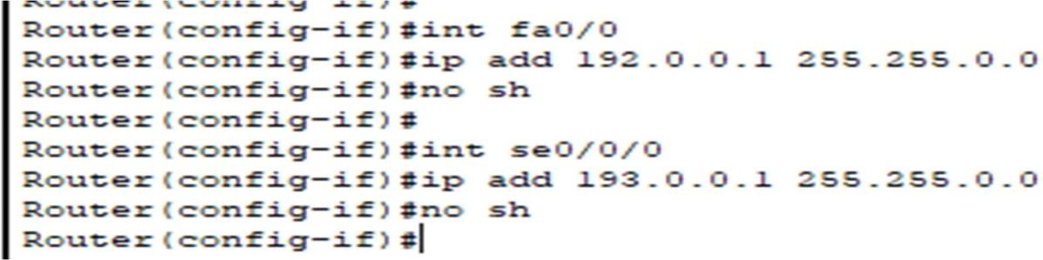

**For Routing Protocols:**

* + - **Rip:**

Router rip

Net IP ADDRESS (ENDING WITH 0)

* + - **OSPF:**

Router ospf PROCESS ID (1-65535) Net IP

ADDRESS (ENDING WITH 0) WILDCARD MASK area (0-255)

* + - **EIGRP**:

Router eigrp PROCESS ID(1-65535)

Net IP ADDRESS (ENDING WITH 0)

**VPN:**

**First end:**

#int tunnel 0

#ip add 100.0.0.1 255.0.0.0 #tunnel sorce se0/0/0 #tunnel destination 14.0.0.2

**Second end:**

#int tunnel 0

#ip add 100.0.0.2 255.0.0.0 #tunnel source se0/1/0 #tunnel destination 10.0.0.1

**VOIP:**

**Commands(Router)**

#ip dhcp pool abc

#net 24.0.0.0 255.0.0.0

#default-router 24.0.0.1

#option 150 ip 24.0.0.1 #telephony-service #maxephone 2 #max-dn 2

#ip source 24.0.0.1 port 2000

#auto assign 1 to 2

#ephone-dn 1

#num 100

#ephone-dn 2 #num 101

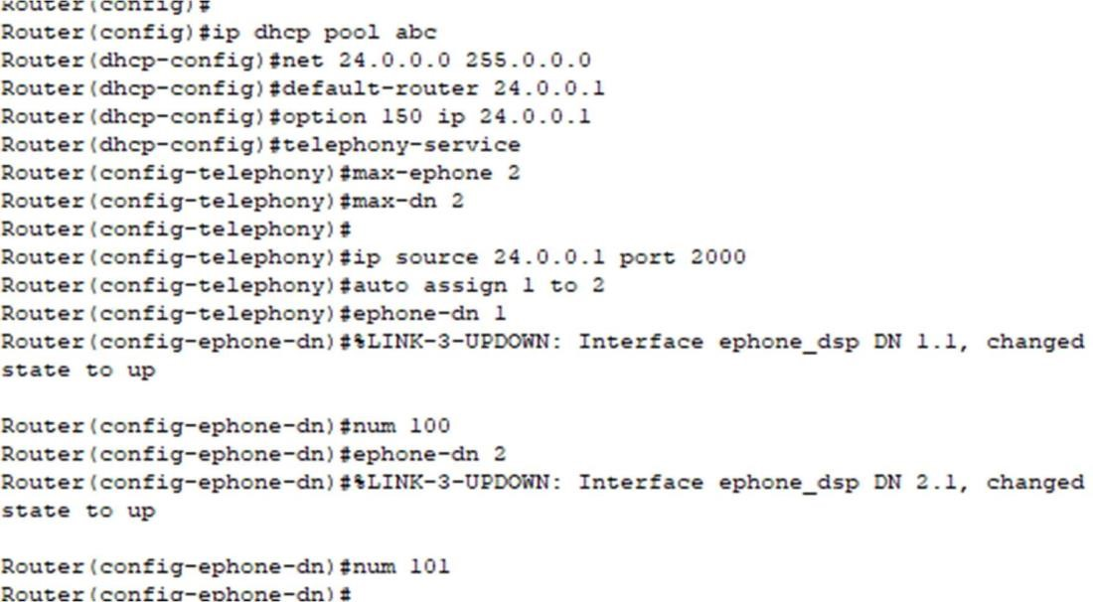

**Commands(switch)**

#Int fa0/15

#Switchport voice vlan 1 #Int fa0/16

#Switchport voice vlan 1

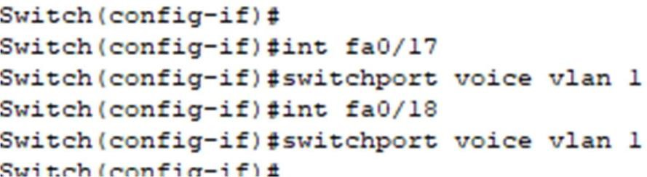

**Commands used for Redistribution:**

# router rip

# redistribute ospf process Id metric 1

# redistribute eigrp process Id metric 1

# router ospf process id

# redistribute rip subnets

# redistribute eigrp process id subnets

# router eigrp process id

# redistribute rip metric 1 100 100 100 100

# redistribute ospf process id metric 1 100 100 100 100

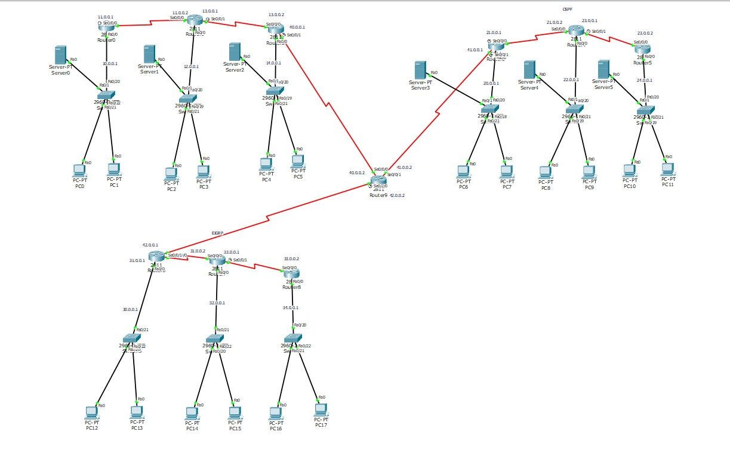**PROJECT SCREENSHOTS**

**Redistribution Implementation**

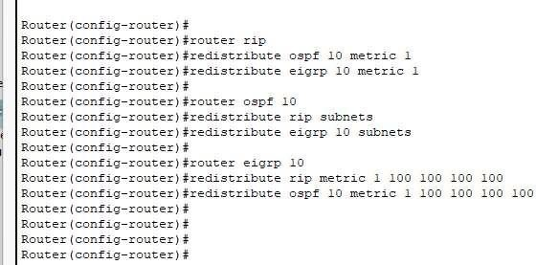

**CONCLUSION:**

Redistribution in networking is the importing and exporting of network routes from one routing protocol to another routing protocol. Routers that run two or more routing protocols can be configured for redistribution. An example is a router that runs OSPF and EIGRP, you can import the network routes from OSPF

Into EIGRP and vice versa. Since routing protocols use different Metrices, you will have to manually assign a metric to redistributed Routes.

**REFERENCES :**

* [StackHowTo-](https://stackhowto.com/what-is-a-protocol-in-networking/#%3A~%3Atext%3D1%20HTTP%3A%20protocol%20allow%20the%20transfer%20of%20files%2Cprocessing%20and%20transport%20of%20IP%20datagrams%20More%20items) https://stackhowto.com/what-is-a-protocol-in-networking/

* [GeeksForGeeks-](https://www.geeksforgeeks.org/what-is-an-ip-address/) https://[www.geeksforgeeks.org/what-is-an-ip-address/](http://www.geeksforgeeks.org/what-is-an-ip-address/)

* [EDUCBA-](https://www.educba.com/networking-devices/)

https://[www.educba.com/networking-devices/](http://www.educba.com/networking-devices/)

* [JavatPoint-](https://www.javatpoint.com/computer-network-topologies) https://[www.javatpoint.com/computer-network-topologies](http://www.javatpoint.com/computer-network-topologies)